UNRECOGNIZED ISOLATED LEFT VENTRICULAR NONCOMPACTION PRESENTING AS STROKE IN A YOUNG WOMAN
G.A. Baquero, D.J. Colegrove, J.E. Banchs
Penn State College of Medicine. Hershey. PA. USA

Isolated left ventricular noncompaction (ILVNC) is a rare form of cardiomyopathy characterized by prominent left ventricular trabeculations and intertrabecular recesses. Most common clinical manifestations are severe systolic and diastolic dysfunction, conduction abnormalities and cardioembolic events. Evidence based recommendations for the prevention of thromboembolic events in ILVNC have not been established. We report the case of a young woman initially diagnosed with hypertrophic cardiomyopathy (HCM) without systolic dysfunction who presented with left hemiparesis due to a large right hemispheric ischemic stroke, later diagnosed with ILVNC.
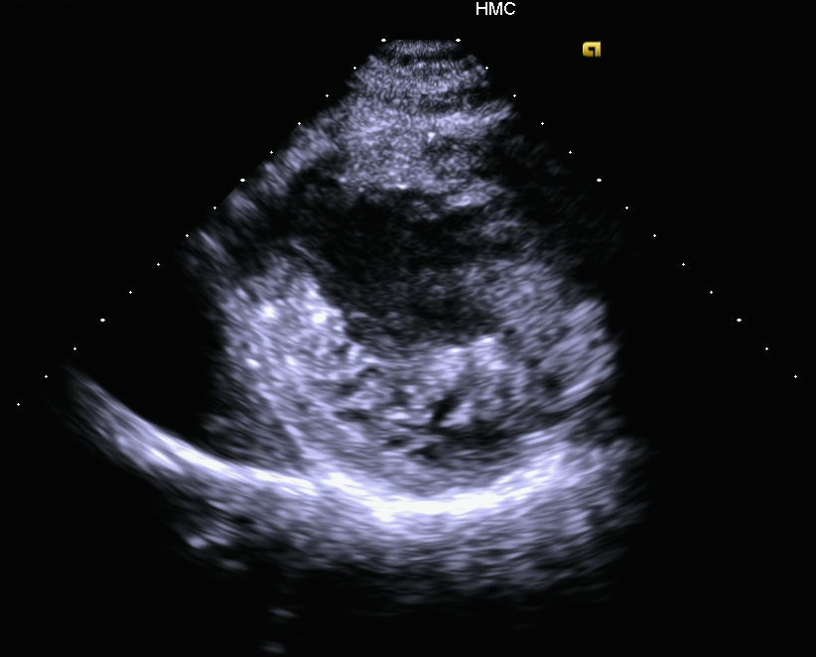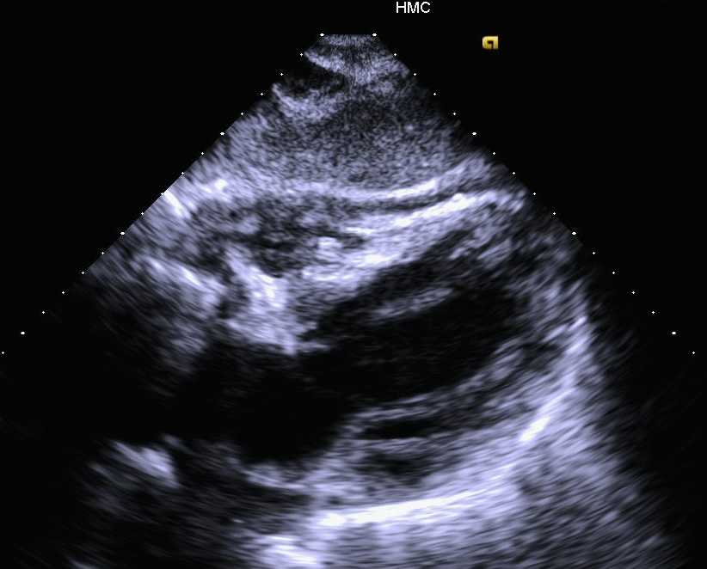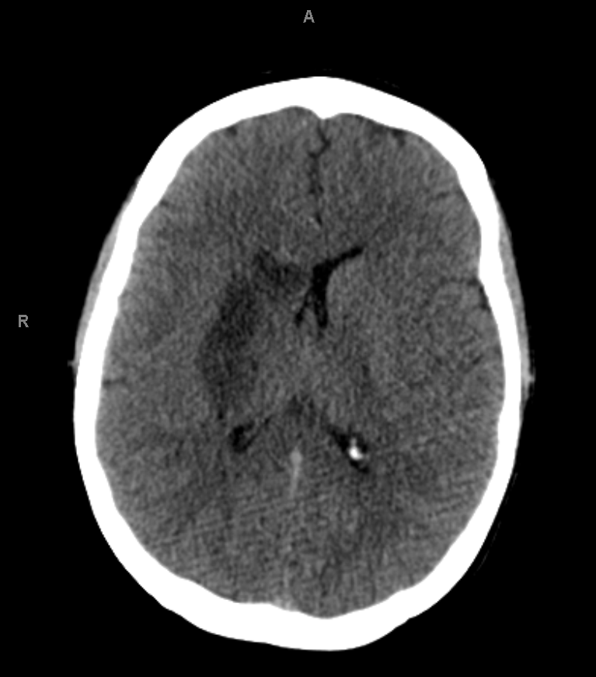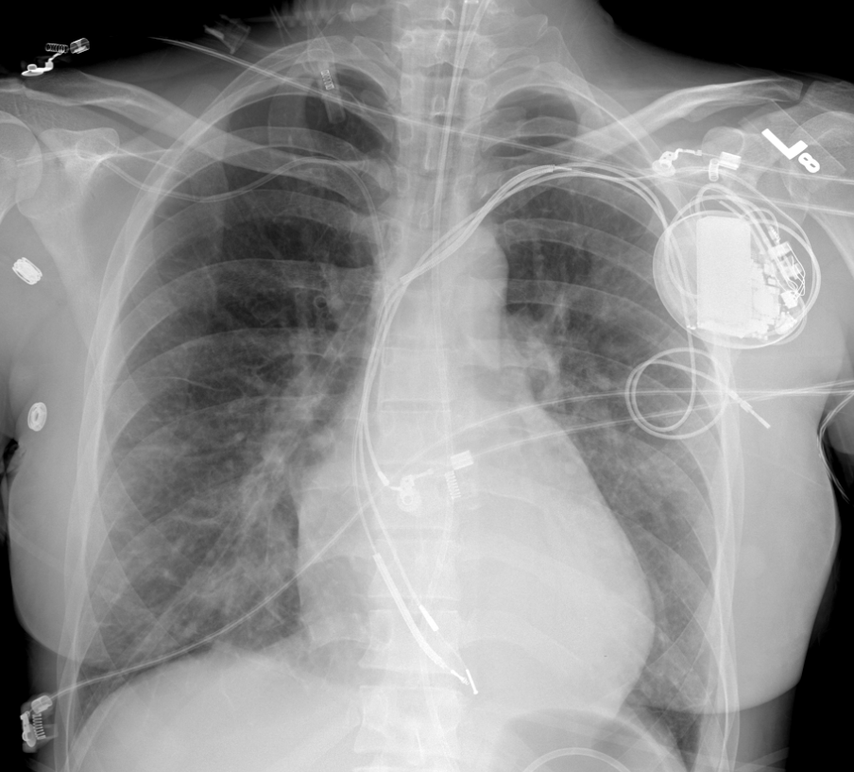

A
B
C
D
A 30-year-old female with a previous diagnosis of HCM and an implantable cardioverter defibrillator (ICD) for primary prevention presented with complaints of left sided weakness and slurred speech. The patient was diagnosed with an ischemic right caudate/lentiform infarct, compatible with a cardioembolic stroke.
A Transthoracic echocardiogram (TTE) showed a thickened left ventricle with marked noncompaction of the postero-lateral walls and moderately reduced systolic function (EF 40%). ICD interrogation showed no arrhythmias or device therapies. The stroke was thought to be a consequence of her ILVNC and reduced systolic dysfunction. The patient was started on anticoagulation.
ILVNC is a rare entity often unrecognized, misdiagnosed as or coexistent with HCM. Most reported cases of ILVNC with systemic thromboembolic events have other associated factors including systolic dysfunction, arrhythmias, coagulopathies or connective tissue disorders. Routine anticoagulation in these patients remains controversial. As suggested in this case, the development of systolic dysfunction in ILVNC may constitute an indication for prophylactic anticoagulation in order to prevent the devastating consequences of cardioembolic strokes.

